EXERCISE 1.1

**NCERT Solutions for Class 10 Chapter 1-**

**Real Numbers**

EXAMBUDDY

**Question 1:  
Express each number as a product of its prime factors:  
(i) 140**

**(ii) 156**

**(iii) 3825**

**(iv) 5005**

**(v) 7429**

**Solution:**

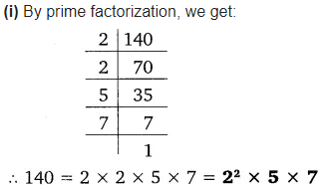

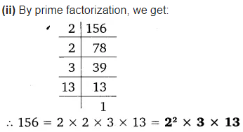

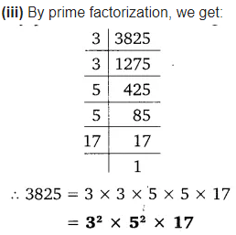

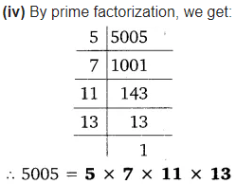

**NCERT Solutions for Class 10 Chapter 1-**

**Real Numbers**

EXAMBUDDY

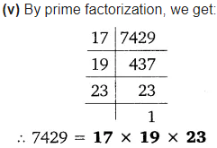

**Question 2:  
Find the LCM and HCF of the following pairs of integers and verify that LCM × HCF = product of the two numbers.**

**i) 26 and 91**

Prime factors of 26 = 2 × 13

Prime factors of 91 = 7 × 13

HCF of 26 and 91 = 13

LCM of 26 and 91 = 2 × 7 × 13

= 14 × 13

= 182

Product of these two numbers = 26 × 91

= 2366

LCM × HCF = 182 × 13

= 2366

Thus, the product of two numbers = LCM × HCF

**ii)** **510 and 92**

**NCERT Solutions for Class 10 Chapter 1-**

**Real Numbers**

EXAMBUDDY

Prime factors of 510 = 2 × 3 × 5 × 17

Prime factors of 92 = 2 × 2 × 23

HCF of the two numbers = 2

LCM of the two numbers = 2 × 2 × 3 × 5 × 17 × 23

= 23460

Product of these two numbers = 510 × 92

= 46920

LCM x HCF = 2 × 23460

= 46920

Thus, the product of two numbers = LCM × HCF

**iii) 336 and 54**

Prime factors of 336 = 2 × 2 × 2 × 2 × 3 × 7

Prime factors of 54 = 2 × 3 × 3 × 3

HCF of the two numbers = 6

LCM of the two numbers = 2 × 2 × 2 × 2 × 3 × 3 × 3 × 7

**NCERT Solutions for Class 10 Chapter 1-**

**Real Numbers**

EXAMBUDDY

= 24 × 33× 7

= 3024

Product of these two numbers = 336 × 54

= 18144

LCM x HCF = 3024 × 6

= 18144

Thus, the product of two numbers = LCM × HCF

**Question 3:**

**Find the LCM and HCF of the following integers by applying the prime factorisation method.**

**(i) 12, 15 and 21**

Prime factors of 12 = 2 × 2 × 3 = 2² × 3

Prime factors of 15 = 3 × 5

Prime factors of 21 = 3 × 7

HCF of 12, 15 and 21 = 3

LCM of 12, 15 and 21 = 2² × 3 × 5 × 7 = 420

**(ii) 17, 23 and 29**

Prime factors of 17 = 17 × 1

Prime factors of 23 = 23 × 1

Prime factors of 29 = 29 × 1

HCF of 17, 23 and 29 = 1

LCM of 17, 23 and 29 = 17 × 23 × 29 = 11339

**(iii) 8, 9 and 25**

Prime factors of 8 = 2 × 2 × 2 × 1 = 2³ × 1

Prime factors of 9 = 3 × 3 × 1 = 3² × 1

Prime factors of 25 = 5 × 5 × 1 = 5² × 1

HCF of 8, 9 and 25 = 1

LCM of 8 , 9 and 25 = 2 × 2 × 2 × 3 × 3 × 5 × 5 = 1800

**Question 4:**

**NCERT Solutions for Class 10 Chapter 1-**

**Real Numbers**

EXAMBUDDY

**Given that HCF (306, 657) = 9, find LCM (306, 657)**

**Solution:**

Given, HCF (306, 657) = 9

LCM (306, 657) = ?

We know that LCM × HCF = [Product](https://www.cuemath.com/numbers/product-in-math/) of two given [integers](https://www.cuemath.com/numbers/integers/)

LCM × 9 = 306 × 657

LCM = (306 × 657) / 9

LCM = 34 × 657

LCM = 22338

**Question 5:**

**Check whether 6n can end with the digit 0 for any natural number n**

**Solution:**

If any number ends with the digit 0 that means it should be [divisible by 5](https://www.cuemath.com/numbers/divisibility-rules/). That is, if 6n ends with the digit 0, then the prime factorisation of 6n would contain the prime number 5.

[Prime factors](https://www.cuemath.com/numbers/prime-factorization/) of 6n = (2 × 3)n = (2)n× (3)n

We can clearly observe, 5 is not present in the prime factors of 6n. That means 6n will not be divisible by 5.

Therefore, 6n cannot end with the digit 0 for any natural number n.

**Question 6:**

**Explain why 7 × 11 × 13 + 13 and 7 × 6 × 5 × 4 × 3 × 2 × 1 + 5 are composite numbers.**

**Solution:**

To solve this question, recall that:

* [Prime numbers](https://www.cuemath.com/numbers/prime-numbers/) are whole numbers whose only factors are 1 and the number itself.
* [Composite numbers](https://www.cuemath.com/numbers/composite-numbers/) are positive [integers](https://www.cuemath.com/numbers/integers/) that have factors other than 1 and themselves.

Now, simplify 7 × 11 × 13 + 13 and 7 × 6 × 5 × 4 × 3 × 2 × 1 + 5.

On simplifying them, we find that both the numbers have more than two factors. So, if the number has more than two factors, it will be composite.

It can be observed that,

7 × 11 × 13 + 13 = 13 (7 × 11 + 1)

= 13(77 + 1)

= 13 × 78

= 13 × 13 × 6 × 1

= 13 × 13 × 2 × 3 × 1

The given number has 2, 3, 13, and 1 as its factors.

Therefore, it is a composite number.

Now, 7 × 6 × 5 × 4 × 3 × 2 × 1 + 5 = 5 × (7 × 6 × 4 × 3 × 2 × 1 + 1)

= 5 × (1008 + 1)

= 5 × 1009 × 1

**NCERT Solutions for Class 10 Chapter 1-**

**Real Numbers**

EXAMBUDDY

1009 cannot be factorized further. Therefore, the given expression has 5,1009 and 1 as its factors. Hence, it is a composite number.

**Question 7:**

There is a circular path around a sports field. Sonia takes 18 minutes to drive one round of the field, while Ravi takes 12 minutes for the same. Suppose they both start at the same point and at the same time and go in the same direction. After how many minutes will they meet again at the starting point?

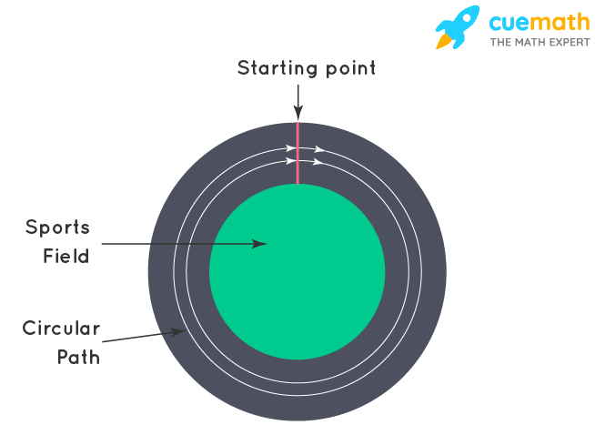**Solution:**

Time taken by Sonia is more than Ravi to complete one round. Now, we have to find after how many minutes will they meet again at the same point. For this, there will be a number that is divisible by both 18 and 12, and that will be the time when both meet again at the starting point. To find this we have to take LCM of both numbers.

Let's find LCM of 18 and 12 by [prime factorization](https://www.cuemath.com/numbers/prime-factorization/) method.

18 = 2 × 3 × 3

12 = 2 × 2 × 3

[LCM](https://www.cuemath.com/numbers/lcm-least-common-multiple/) of 12 and 18 = 2 × 2 × 3 × 3 = 36

Therefore, Ravi and Sonia will meet together at the starting point after 36 minutes.